Payton Bramer

Task #1

# of tables in AP: 7

# of columns in vendor: 12

# of columns with int data type: 3

# of varchar in vendor: 8

# of char in vendor: 1

Task #2

AP Database Diagram



Terms table primary key: TermsID

Terms Table relations: Ventors, resources

Primary Key data type: INT

InvoiceLineItems Table Primary Keys: InvoiceID, InvoiceSequence

InvoiceLineItems Table Relations: Invoices and GLAccounts

Primary key data types: INT

Task #3

a)  How many tables are in the Examples database: 19 tables

b)  How many tables are in the Northwind database: 13 tables

c)  In the Examples database, how many columns are in the Customers table? 8 columns

d)  In the Examples database, how many columns in the Invoices table have a data type of int?

- 2

e)  In the Examples database, how many columns in the PaidInvoices table have a data type of money? 3

f)  In the Examples database, how many records are in the SalesReps table? 2

g) In the Examples database, what is the primary key in the SalesReps table? RepID

h)  In the Examples database, Project table, what is the maximum number of characters allowed in the ProjectNo column? 5

i)  In the Examples database, Projects table, can the ProjectNo column have a value of null? No

Task #4

Detached examples

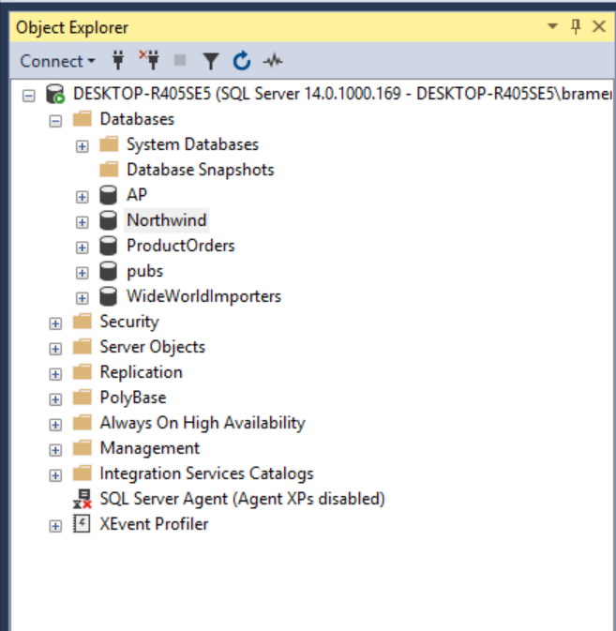

Attached examples

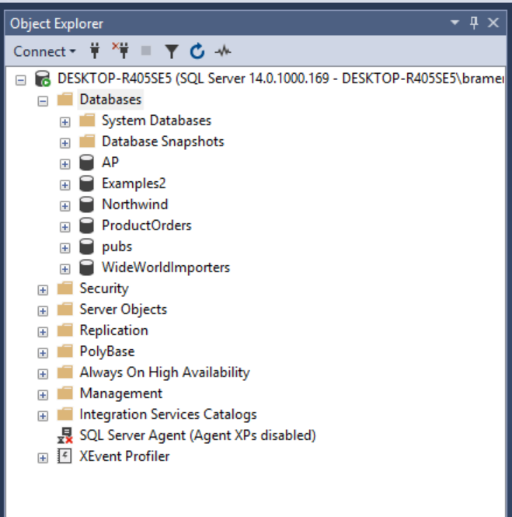

Backup examples

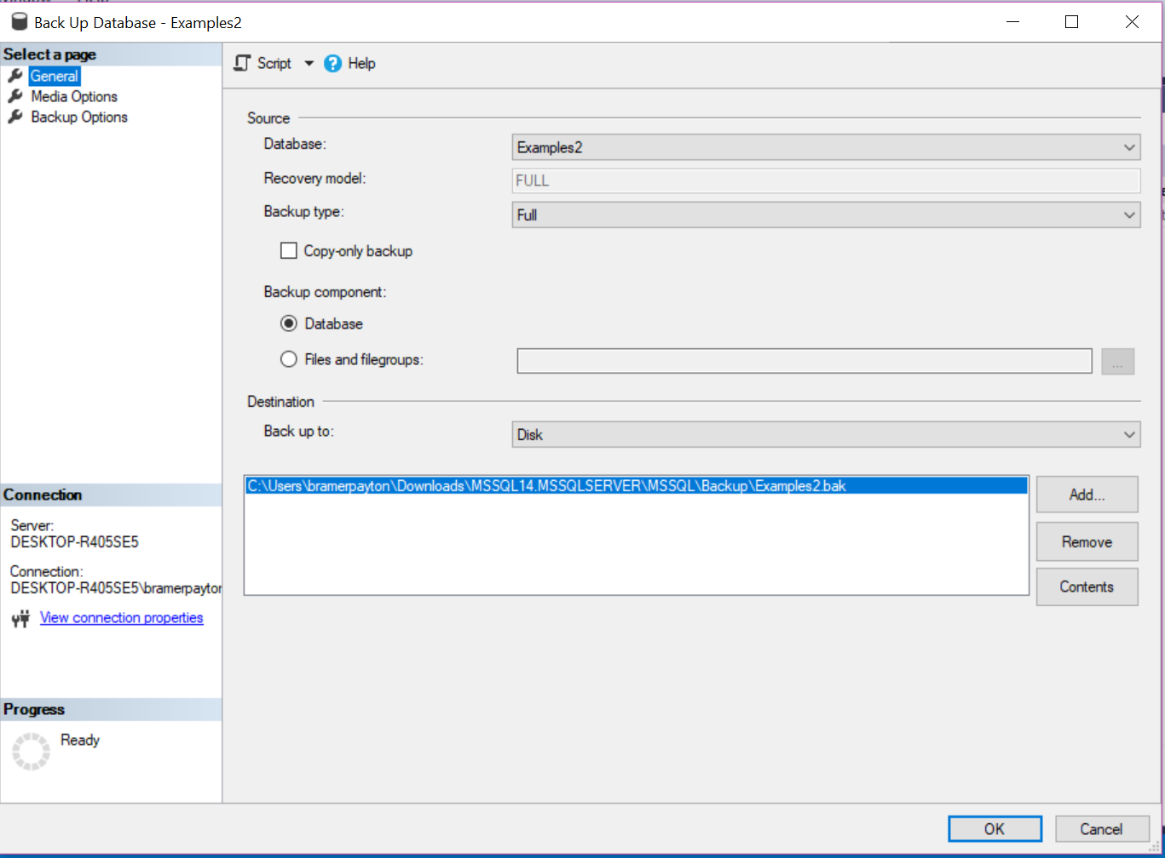

Restore examples

